INF1103 Lab 8 Submission
1: Python files (10 files) ✅
2: Predict first Notes:
Section 2.2 (association): predict what happens after del supplier
Prediction: Each Product can still display its supplier information. del only removes the variable name supplier, not the Supplier object. Each Product stores its own reference to that object, so the object stays alive.
What happened: Both products still printed Supplier ID: S001 | Name: Acme Supplies | Email: sales@acme.com after del supplier, and both products shared the same Supplier object (True).

Section 3.2 (aggregation): will the Product still work after removal from Inventory A?
Prediction: Yes. remove_product only removes the reference from the inventory's list. The Product object is independent of the Inventory, and the variable mouse still refers to it, so it can still be used and added to another inventory.
What happened: After removal, find_product returned nothing for Inventory A, but mouse.display_information() and update_stock(45) still worked, and the same object was added to Inventory B (shown with stock 45).

Section 4.3 (composition): same Product in two Orders, how many OrderLine and Product objects?
Prediction: Two OrderLine objects (each Order creates its own) and one Product object that both lines refer to.
What happened: line_1 is line_2 gave False and the two id() values differed (4321560624 and 4321431056). The product reached through each line was the same object (True) with the same id (4321429776).

Section 7.2 (polymorphism): what does get_fulfilment_info() print for each product?
Prediction: PhysicalProduct prints "Physical product: requires physical shipping." and DigitalProduct prints "Digital product: delivered digitally via download." Each object supplies its own overriding version.
What happened: The laptop (PhysicalProduct) printed the physical shipping message and the eBook (DigitalProduct) printed the digital download message, from a single loop over the inventory.

3: LSP review (Section 6.3)
Expectation preserved: Product establishes that update_stock(quantity) sets the stock and returns True, or returns False and leaves the stock unchanged if quantity is negative. Neither PhysicalProduct nor DigitalProduct overrides update_stock, so both keep exactly this meaning. In my test, Inventory.update_stock returned True for valid values on both types and False for -1 on both, without Inventory checking the subclass.
Diagnose: Yes, this violates LSP. Product promises that update_stock(quantity) works and returns a bool, but the proposed DigitalProduct raises NotImplementedError, so any code written for Product, such as Inventory.update_stock, crashes when it is given a digital product. I would change the subclass by removing the override so DigitalProduct keeps the inherited behaviour, because in this system a digital product already has a stock quantity (for example, available licences). Adding isinstance checks to Inventory would only hide the bad design.

4: Polymorphism and LSP (Section 7.3)
show_product_details(product: Product) only calls display_information() and get_fulfilment_info(), which are defined by the Product abstraction. When I pass a PhysicalProduct, it prints the weight and the physical shipping message, and when I pass a DigitalProduct, it prints the download size and the digital delivery message. Python picks each object's own overriding method at runtime without any isinstance check, which is polymorphism. LSP is what makes this safe: both subclasses keep Product's contract (the same methods, the same inputs and the promised return types), so the function works unchanged for both and would also work for a new Product subclass added later.

5: AI use note (Section 8)
One thing I accepted: The relationship choices in the AI-drafted UML: Supplier to Product as an association (Supplier 1 to 0..* Product), Inventory to Product as an aggregation with 0..1 at the Inventory end, and Order to OrderLine as a composition with exactly 1 at the Order end. I checked each against Section 1: for example, supplier: Supplier in Product is only a stored reference with no whole-part meaning, so it is an association and not aggregation or composition.
One thing I changed: When I first exported the diagram, the Product and CanBeShipped boxes showed a blank <> instead of «abstract» and «interface». I had the diagram regenerated with the labels fixed and re-exported it.

The following are screenshots demonstrating the relationships and LSP using test code:
Section 2:
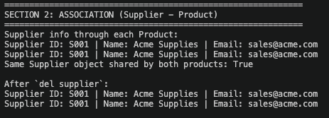
Section 3:
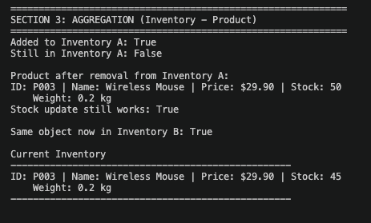
Section 4:
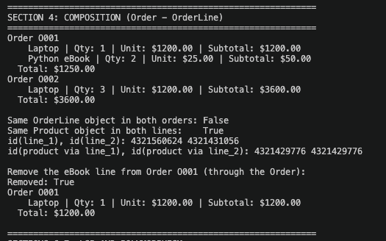
Section 6-7:
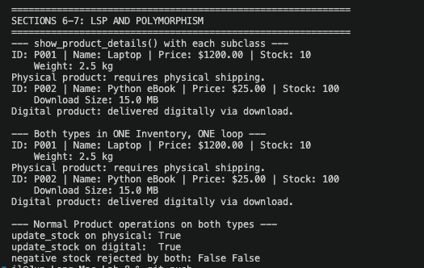
6: Updated UML Class Diagram ✅
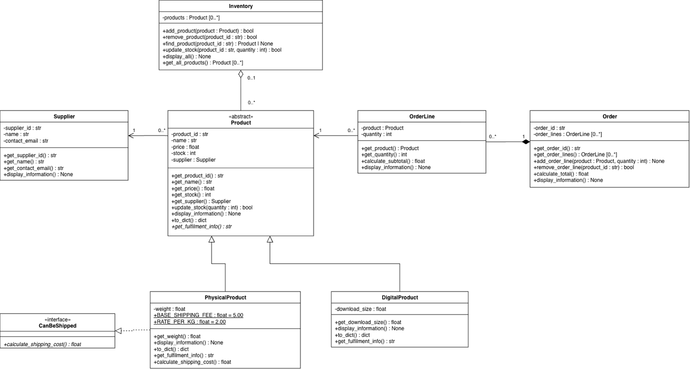

7: Evidence of type hints in the implementation: (product.py)
product.py:
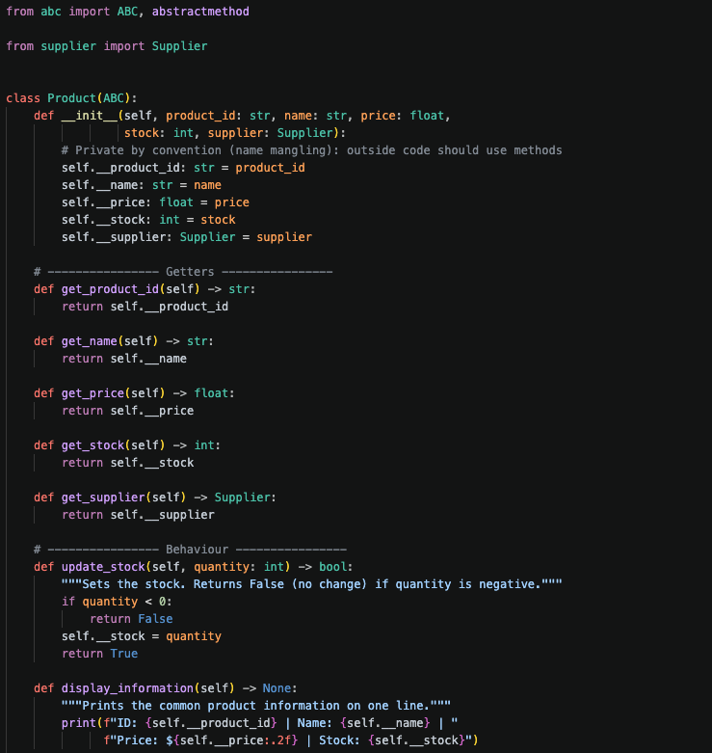
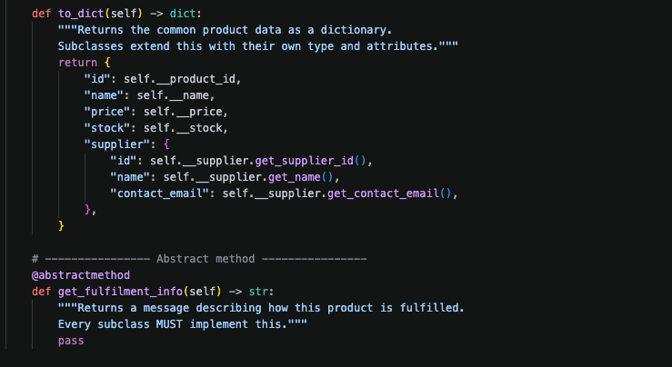

8: Git log ✅
9: Docker container running successfully and Screenshots of my program accepting input and producing the expected results:
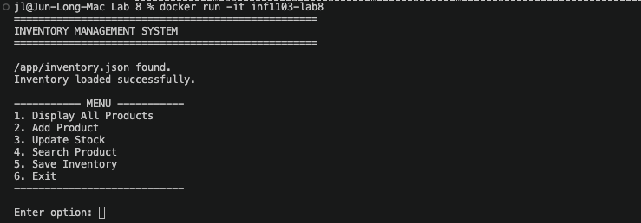
Add Product with supplier details:
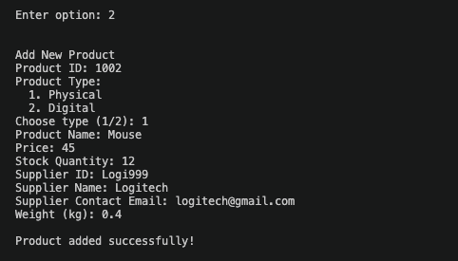
Search product:
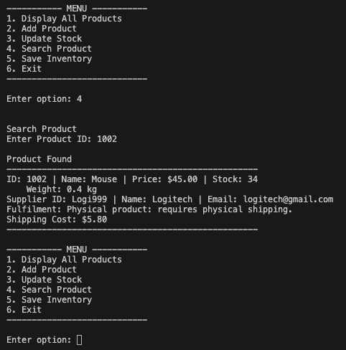
The rest same as lab 7.

